Shabbos Stories for
Parshas chayei sarah 5782
Volume 13A, Issue 10 - 24 Cheshvan/October 30, 2021
Printed L’illuy nishmas Nechama bas R’ Noach, a”h

For a free subscription, please forward your request to keren18@juno.com
Past stories can be found on the website ShabbosStories.com

Almost at the Peak

Chazal tell us that whenever the Torah writes “rak, only,” it is excluding something. Therefore means והיית רק למעלה ,(13:28( the Jewish nation will be on top of all nations, and they will enjoy immense success. Everything will be good for them – but not everything. Something will be missing.

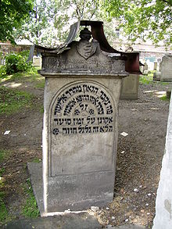
The Chasam Sofer, zt”l and the grave of Reb Eliezer
Ashkenazi in Remah Cemetery in Kraków

The Chasam Sofer zt’l writes in the name of Reb Eliezer Ashkenazi (author of Maasei Hashem) that this is for our benefit. Because when you reach perfection, the only way to go is down. It states (Mishlei 16:18), שבר לפני גאון”, Before breaking, one becomes great.” So it is better when something is lacking.
Several times in his sefarim, the Chasam Sofer expresses that a perfect life isn't perfect at all. People want to have a life without any problems at all, but the Chasam Sofer clarifies that the problems are what keep us going. They give us a challenge to conquer, a reason to wake up in the morning to amend. He tells a story of someone in his time who committed suicide. On his suicide note he wrote, "I have everything. Nothing is lacking. And that's why I'm taking my life."

A Brachah that Can
Also be a Terrible Curse
When the Chasam Sofer explains the birchas kohanim, he expresses that the brachos give parnassah, peace, and everything good. "But this brachah is a נמרצת קללה, like a terrible curse," he writes, because he won't find purpose in life. He answers that the answer is found in the next verse of birchas kohanim, ,ושמו את שמי על בני ישראל ואני אברכם that Klal Yisrael can make their goal in life success in Torah and in avodas Hashem, and that will grant them a purpose in life. But for many, a perfect life is anything but perfect. As much as we don't want the problems, what would we do with our time if we didn't have problems to deal with? Life would become boring.
Therefore, we receive Hashem's blessings, רק והיית למעלה ,you will be on top, things will be good for you – but not everything. Even at the best times, something will be lacking, and that is for our benefit. Reb Eliezer Ashkanazi experienced firsthand that it isn’t good to be all the way on top.

Appointed to be a Minister to
The King of Mitzrayim (Egypt)
This is what happened to him: Reb Eliezer Ashkenazi lived in Mitzrayim and was renowned for his honesty, cleverness, and vast wisdom. The king of Mitzrayim also heard of Reb Eliezer's greatness, and he appointed him to be one among his ministers. The king of Mitzrayim didn't regret appointing Reb Eliezer Ashkanazi at this high position. Reb Eliezer's wisdom helped the king run his country smoothly and successful, and the king loved Reb Eliezer very much. He even gave Reb Eliezer his signet ring, an honor that only Reb Eliezer received.

Other Members of the Court
Were Highly Jealous of the Jew
The other ministers, advisors, and officials in the king's cabinet were jealous that the king loved Reb Eliezer so much. They waited for the opportunity to harm Reb Eliezer Ashkenazi and lower his rank. The king's birthday was approaching, and he invited his cabinet to his birthday celebration.

One of the many bridges crossing the Nile River in Egypt.

Reb Eliezer was crossing a bridge over the Nile to go to the celebration, when another minister asked him whether he forgot to bring the king’s signet ring. Reb Eliezer took out the ring to show that he has it with him, and the jealous officer grabbed it and threw it to the Nile. Reb Eliezer jumped and caught the ring in mid-air, before it fell into the waters below. It was a miracle that he caught it.
At the party, the king accorded Reb Eliezer immense honor, and all the other officials cringed with jealousy. After the celebration ended, the king walked Reb Eliezer out of the palace. Once again, this roused the wrath of Reb Eliezer's fellow officials. Reb Eliezer wasn't happy that he received so many honors at the party. He reminded himself that Shlomo HaMelech, the wisest of all men, said ,לפני שבר גאון :(18:16 Mishlei( “Before falling, one becomes great.”

Reb Eliezer Thought it was Time
To Quickly Flee the Country
Reb Eliezer feared that the honor he received was a sign that he would soon plummet and lose everything. It was time to leave the country. That very night (following the king's party) he tossed precious gems into a box and boarded a ship for Turkey. Indeed, this act saved his life. Later he heard that after he left the birthday celebration, some of the king's officers approached the king with terrible false claims about Reb Eliezer.
The king believed them and ordered his arrest. But by the time the police came to his home, he was already on his way to Turkey. He was saved once, but soon his life was at risk again. Not far from the Turkish port in Constantinople (Istanbul), the ship hit a rock and sunk.

The Port of Old Constantinople

All passengers jumped into the water and tried to swim ashore. Reb Eliezer realized, with a heavy heart, that he couldn't take along his box filled with gems, but he was fortunate to find a plank floating in the water, which helped him reach the shores of Constantinople. Reb Eliezer recovered from his ordeal at sea, and he thought over what’s happening to him. Just a few days before, he had wealth and honor. He was the Egyptian's king's highest ranking official after the king. And now he was a stranger in a foreign land, without money and without prestige.
Why was he being punished? After contemplating this matter, he concluded that he was being punished for bitul (neglecting the study of) Torah. When he was serving in the king's palace, his many obligations prevented him from properly studying Torah. He made a firm resolve to correct this error. He was ready to live simply, as long as he can devote himself to studying Torah.

Rented a Tiny Apartment in Order to be
Able to Devote Himself to the Study of Torah
Reb Eliezer heard that there was a tiny apartment for rent, which supplied daily meals. The apartment was owned by a poor Jewish widow, and the meals weren't much; mostly dried up bread. But Reb Eliezer agreed to move there. It wasn't what he was used to. Up until very recently he lived a life of luxury. But he didn't mind, so long as he could devote himself to studying Torah.
One day, the widow didn't have dry bread. All she served was watery soup. That's all she could afford that day, and that was all Reb Eliezer had to ward off his hunger. To make matters worse, there was a spider in the soup! Reb Eliezer realized that he had reached a nadir, and he knew that now his mazal will turn around and things will become better. Because when one is at the top, the only way to go is down, and when one is at the lowest rank, the only way to go is up.

The Sultan was Searching
For a New Chess Partner
Later that day, he heard an announcement: "The sultan seeks a chess partner to play with." The sultan's previous chess partner died, and he sought a replacement. Reb Eliezer applied for the position. The sultan played a game of chess with Reb Eliezer and was impressed with Reb Eliezer's wisdom and expertise. He immediately hired him for the position and appointed him to be a minister.
Reb Eliezer knew that he must be cautious from bitul Torah. So he kept track of the hours he played with the sultan, and he made up those hours studying Torah at the wee hours of the night. Sometimes he was very tired, but he remembered that he was once punished for bitul Torah study, and he didn’t want to make the same mistake again.
One night, while playing chess with the sultan, Reb Eliezer fell asleep in the middle of the game. That was extremely disrespectful; the sultan could take off someone's head for such an offense. However, the sultan liked Reb Eliezer, and the sultan placed his own cushion under Reb Eliezer’s head.

On the Move Again
When Reb Eliezer awoke, he realized he reached another peak, and that meant his descent was soon coming. So, he left Turkey and moved to Posen, where he served as the rav. Afterwards, he went to Krakow. He was the rav of Krakow and that is where he is buried. Because this is the way of the world: When one reaches the highest levels and everything is going his way, the only way to go is down. And in contrast, when everything is bad, things have to improve. It can't become worse than it is.

Reprinted from the Parshas Ki Savo 5781 email of Torah Wellsprings: Collected Thoughts from Rabbi Elimelech Biderman.

The Bishop Who
Saved 1500 Jews
By Rivka Ronda Robinson

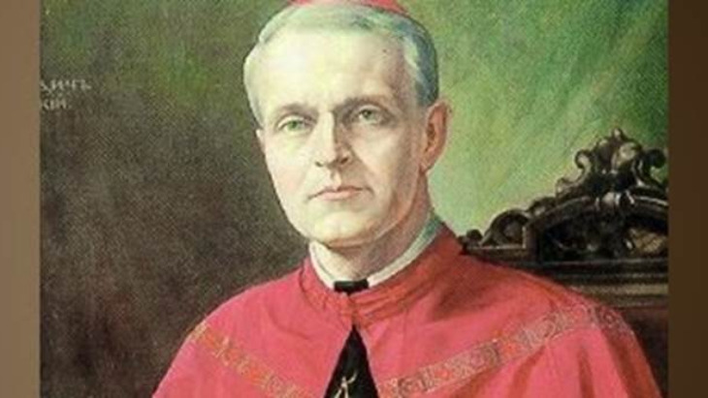
Pavel Peter Gojdic suffered mistreatment and humiliation for his outspoken defense of Jews during the Holocaust.

This is the story of a righteous gentile and his unsaintly nemesis. Pavel Peter Gojdic, a humble Catholic monk, was born in 1888 in Slovakia, where he served as resident bishop during World War II and a friend of the Jews who saved many lives.
Nazi Germany occupied the region in 1938 and quickly went about issuing anti-Jewish orders. Local authorities cooperated, limiting Jews’ freedom of movement and excluding Jewish children from non-Jewish schools.
At personal risk as apostolic administrator, Gojdic openly spoke up in favor of Jews from the beginning of their persecution in Slovakia. “On January 25, 1939, two days after the establishment of a special committee by the Slovak autonomist government charged with defining the program for the solution of the Jewish question, the bishop wrote a special letter addressed to all parishes in his Presov diocese,” wrote Yad Vashem, Israel's Holocaust museum.
“In this letter he warned about disastrous results which might be caused by these discriminative policies. He reminded people of the basic principles of their belief – that every human being has equal rights when he faces God. He also warned of the consequences of Nazi ideology and racism.”

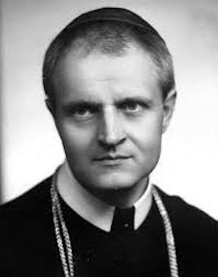
Pavel Peter Gojdic

Gojdic's activities did not sit well with the fascist Slovak state. Fellow priests turned on him. In the summer of 1939 they wrote a memorandum expressing their dissatisfaction with Gojdic’s actions. He resigned a few months later.
In 1940 the Vatican accepted his resignation from the position of apostolic administrator, but at the same time appointed him as bishop of the Presov, Slovakia, diocese. This only increased the tension between him and the government.

Nemesis Condemns Slovak
Jewry to Destruction
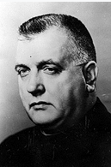
Jozef Tiso, yemach shemo

Meanwhile, Slovakia’s new president, Jozef Tiso – also a priest – began expropriating Jewish property and deporting Jews to German-occupied Poland. He resisted most pressure from the Vatican and Jewish groups to end deportations.
Historian James Mace Ward, a visiting Fellow at the United States Holocaust Memorial Museum, cited a conversation in which Tiso regretted exempting 18,000 Jews from expropriation and deportation, due to
his belief that they were sabotaging the economy.

Tiso Hanged
Ward’s research portrays Tiso as a man who helped condemn Slovak Jewry to destruction. Ultimately, Tiso met a violent fate himself. After World War II ended, a reunified Czechoslovakia convicted and hanged him for treason, suppression of freedom and crimes against humanity.
Despite posthumous efforts to brand Tiso a saint, Ward concluded that he was no saint.

On the other hand, Bishop Gojdic helped refugees, prisoners and inmates of concentration camps, and became known as “the man with a heart of gold.” He is credited with directly or indirectly saving as many as 1,500 Jews.

Righteous Gentile Saved Countless Lives
In 2007 Yad Vashem recognized Bishop Gojdic as one of its Righteous Among the Nations. Its webpage about him reports: “On October 26, 1942, the Slovak Security Services informed the 14th Department of the Ministry of Interior about a high number of fictitious conversions taking place.
The report pointed out several cases when only one member of a Jewish family converted to Christianity in order to defend his whole family. Out of 249 Jewish families only 533 Jews converted to Greek Catholic or Russian Orthodox faith in order to rescue another 1500 members of their families, who did not convert. Apart from that, most of those who had converted continued to actively pursue Judaism either in an open or a hidden manner.”

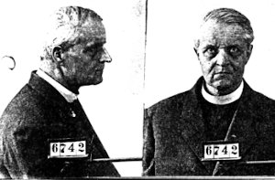
Photos of Bishop Gojdic after his arrest by the Communists in Czechoslovakia
Refusing to renounce his religion, he was given a life sentence for treason by the Communist state, Czechoslovakia.
Though he survived the Nazis, Bishop Gojdic endured a life sentence in prison when the Communist regime made the Greek Catholic Church illegal. The many letters written by Jews who were grateful for his work had no effect on this sentence. He died from cancer in the prison hospital of Leopoldov Prison in 1960, on his 72nd birthday.

Reprinted from the August 23, 2021 website of Aish.com

The Doctor and the Rabbi

A Yid studied many years in university to be a doctor, and graduated at the top of his class. He was certain people will flock to him, so he opened a first-class medical clinic in an expensive area. The rent was high, but he was certain he could cover the expenses.
But things didn't happen as he expected. The clinic was empty, too often. People weren't rushing to him, as he thought they would. Those who came recognized that the clinic isn't very active, which made them wonder whether the doctor was as competent as he advertised.

The Rabbi Asks the Doctor
About How His Clinic is Doing
One day, after shacharis, the rabbi of his shul asked him how his new clinic was coming along. "Terrible," he replied. "I'm not sure what the problem is, but either people stopped getting sick or they are going to my competitors."
The rabbi answered with wise counsel. "When someone calls for an appointment,” he said, “don't tell him to come in right away. Tell him that the only open slot is in three months. That way, people will think you are a very busy, sought after doctor, and that will build your reputation.
The plan worked. Word went out that there is a superb doctor who heals the ill when other doctors fail. "It is worth waiting the three months for the appointment," people were saying.
One day, the rabbi wasn't feeling well, and after shacharis, the rabbbi spoke with doctor and requested an appointment. The doctor replied, "There's a slot open in three months from now..."
The rabbi replied, "I'm the one who taught you to do this. Are you going to pull that trick on me, too? You should arrange an appointment for me immediately!"

The Important Lesson of the Nimshal
The nimshal is: A poor person davens for wealth and Hashem grants it to him. But then he doesn’t have time for Torah and tefillah. He is too busy with his business. Hashem says, "You don't have time even for Me? I'm the one who gave you your wealth. I'm the one who made you so busy in the first place. You should certainly have time for me."

Reprinted from the Parshas Ki Savo 5781 email of Torah Wellsprings: Collected Thoughts from Rabbi Elimelech Biderman.

Why Davening is Like
An Old Kugel Pot

The Tzadik Rav Alexander Ziskind, zt”l, the author of the Sefer Yesod V’Shoresh HaAvodah, would regularly Daven in a nearby Shul. Even when he got older and he didn’t have the same strength that he used to, he still pushed himself to Daven in his set place.
His Rebbetzin saw him struggle to get to Shul, and asked him why he bothers himself so much to do this. Perhaps it would be a good idea to arrange a Minyan for him in their house, and this way he wouldn’t have to walk anywhere. Certainly, she said, his Tefilos would be answered from the house no less than they would be answered from Shul.
The Tzadik answered her, “You know from experience that when you prepare a Kugel for Shabbos, what pot will you use? Wouldn’t you use the old one, which has a lot of oil absorbed in its walls? It then only needs a little oil to be added to the Kugel, and it will come out tasting good.
This is not so if you used a new pot, where even if you add a lot of oil, the oil will be absorbed in its walls and the Kugel will not have any flavor. Tefilah is like that Kugel! The Shul is a place where the walls are soaked in extra Kedushah from all the Tefilos that take place there and from all the Torah that is learned. Even if someone Davens without all the proper intentions, his Tefilah will ascend before Hashem.
This is not so with the Tefilah that takes place in a private home, because this is a place where the walls are not soaked with so much Torah and Tefilah, and sometimes there are conversations that are not appropriate that take place there. Who knows if such a Tefilah will ascend to Shamayim?”

Reprinted from the Parshas Ki Savo 5781 email of Rabbi Yehuda Winzelberg’s Torah U’Tefilah.

The True Ruler of the
Satmar Rav’s Home

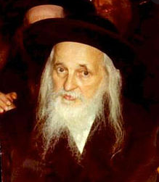

Rav Gamliel Rabbinowitz, Shlit”a, related that a Satmar Chasid, who was very attached to his Rebbe, the author of ‘VaYoel Moshe’, once told him the following story. On Erev Shabbos Kodesh, there is no time for the Satmar Rav to receive the public. However, since this man was the Rav of the Community of the Satmar Chasidim, and he had to resolve questions regarding Shabbos, this man was allowed to visit with the Satmar Rav.
When he went inside the Rav’s home, he saw the Rebbetzin carrying the tray of Shabbos candles to the large table in the dining room. The Satmar Rav asked her, “Why are you setting up the candles here in the house?”
Their custom was that if the Rebbe was arranging a Tish on Shabbos night in the large Bais Medrash, the Rebbetzin would light her candles there, since it was preferrable to light candles where they would eat.
The Rebbetzin replied, “I don’t want you to make a Tish today, because you do not have the strength for it. Today, you will have your Shabbos Seudah in the house.”
The Rebbe disagreed and said, “This is not possible. I already let several people know that I am making a Tish, and many guests are coming for Shabbos, among them some people that need Chizuk, encouragement, and I must be there for them!”
They discussed the matter between themselves, and ultimately, the Rebbetzin prevailed, and the Rebbe agreed that he would not make a Tish that week.
The man, who was quietly waiting on the side, saw this incident take place, and he was bothered. He was under the impression that the most influential person in the world was the Satmar Rav. The whole world trembled from him. And here, he saw that the Rebbetzin was more powerful than the Rebbe!
While he was still standing there, the Satmar Rav approached him, as if he had read his mind. With his famous smile, he said to the man, “When it comes to Shalom Bayis, tranquility in the house, everything, without exception, depends on the Middah of giving in pleasantly. Therefore, the one who is really the winner is the one who yields to the other!”

Reprinted from the Parshas Ki Savo 5781 email of Rabbi Yehuda Winzelberg’s Torah U’Tefilah.

The Tzadik’s Heavy Chair

The story is told about the Imrei Chaim of Vizhnitz, who went for a while to Williamsburg in the United States, in order to get some rest and to recuperate. On the advice of doctors, he took a walk every night, to breathe the air and maintain good health. He was very careful that whenever he went out on a stroll, he instructed his Shamash, attendant, to take along his chair with them.
Now, the Rebbe’s chair was not small and easy to carry. No one understood this strange custom. Even if the Rebbe wanted to sit and rest during his walk, there were many benches to sit on along the way.
One time, the Shamash built up the courage to ask the Rebbe about this practice.
The Imrei Chaim replied, “Dovid Ha’melech says in Tehilim (1:1) ‘Praiseworthy is the man who does not go in the way of the wicked, or has stood on the path of the sinners, and he does not sit in the place of scorners.’ It is difficult to understand this.

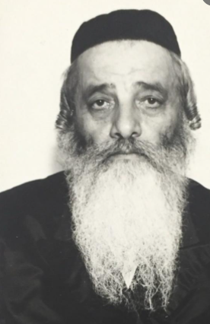
Rabbi Chaim Meir Hager, zt”l, the Imrei Chaim (1888-1972)

Why does Dovid say not to sit in a place of scorners? Wouldn’t it make more sense to advise not to sit with scorners? The answer is that Dovid Ha’melech wanted to instruct us that it is not only dangerous to sit among mockers and scorners, but it is even dangerous to sit in the place where they sit. That place has been contaminated, and the Tumah, impurity, clings there, and whoever sits in that spot, the Tumah will attach to him as well.”
The Rebbe said, “All the benches that we pass on the way, were sat on by all types of lowlifes that walk the streets, and I do not sit on a place like this. This is why I insist that we bring along a chair from home, so that I can sit on it whenever I need to.”

Reprinted from the Parshas Ki Savo 5781 email of Rabbi Yehuda Winzelberg’s Torah U’Tefilah.

